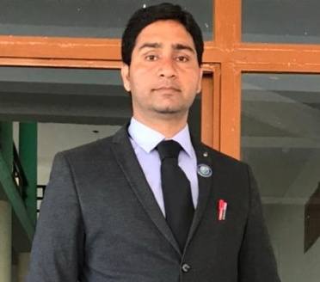

Amit Verma
Assistant professor in Nimbus School of Education
Area
Primary Area: Education
Secondary Area: Humanities,
Contact: 7017930866
Email: amitverma5443@gmail.com
Phone: +91-7017930866
Education
• Master of Education, SDBIT Dehradun (HNBGU)
• Bachelor of Education, Trinity College (HNBGU)
• Master of Art, Bachelor of Art

Teaching
• Political Science
• Contemporary India and Education
• Gender School and Society

Research Area
Indian Polity, Indian Philosophy

Academic Experience
Faculty Member, Nav Chetna School of Education , Dehradun, May 2018 to August 2021.
Faculty Member, Nimbus School of Education, September 2021 onwards.

Professional Experience
Nimbus School of Education
Nav Chetna School of Education

